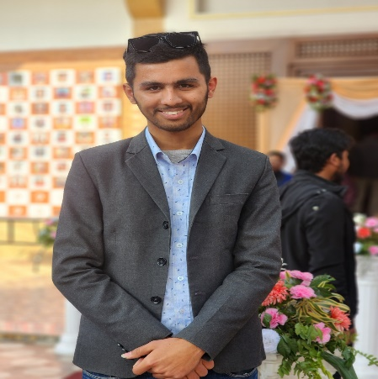**Curriculum vitae**

**Name:** Prabin Acharya

**Address**

Permanent Address

* Indrawati Gaupalika ward no 05, sindhupalchok

Temporary Address

* Budhanilakantha 12 kapan Kathmandu

**Email:** [acharyaprabin17@gmail.com](mailto:acharyaprabin17@gmail.com), [acharyaprabin2059@gmail.com](mailto:acharyaprabin2059@gmail.com)

**Phone No:** 9861327411

**Education**

* +2 in science
* Bachelor in computer engineering

**Experience**

* Minor project in lung cancer prediction using CNN algorithm
* Major project in Age group classification using deep learning
* Case study on patan industrial area
* Python training
* HTML and CSS basics

**Research**

* Research on CNN algorithm
* Research paper preparation on lung cancer prediction

**Certification**

* Python course
* Web development course